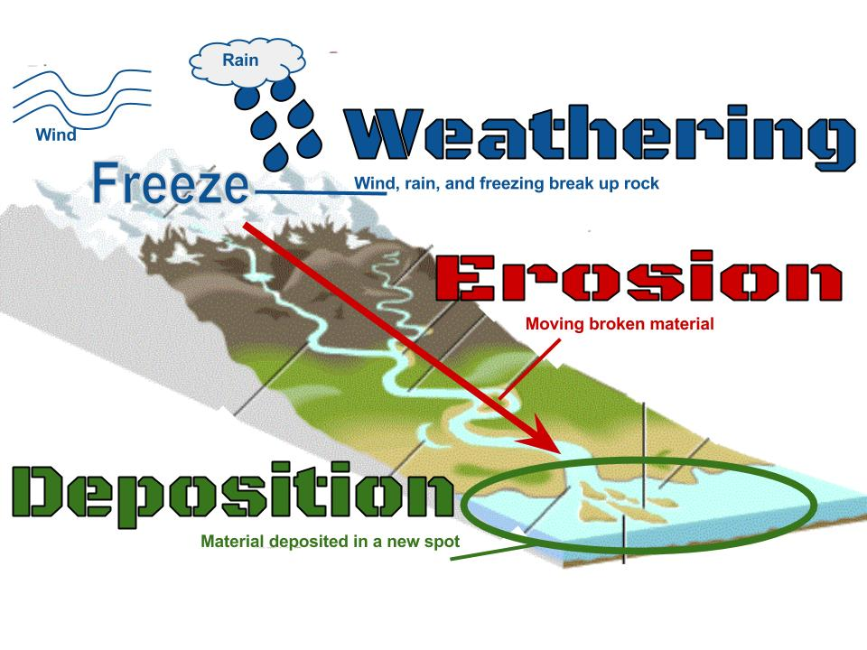
WEATHERING- the process of rocks being broken down into smaller pieces called SEDIMENTS.
2 types of Weathering:
- Mechanical weathering- rocks are broken down by physical means
- Chemical weathering- rocks are broken down by chemical reactions

