https://www.youtube.com/watch?v=7CnjoCu1154

Examples | How is it formed?
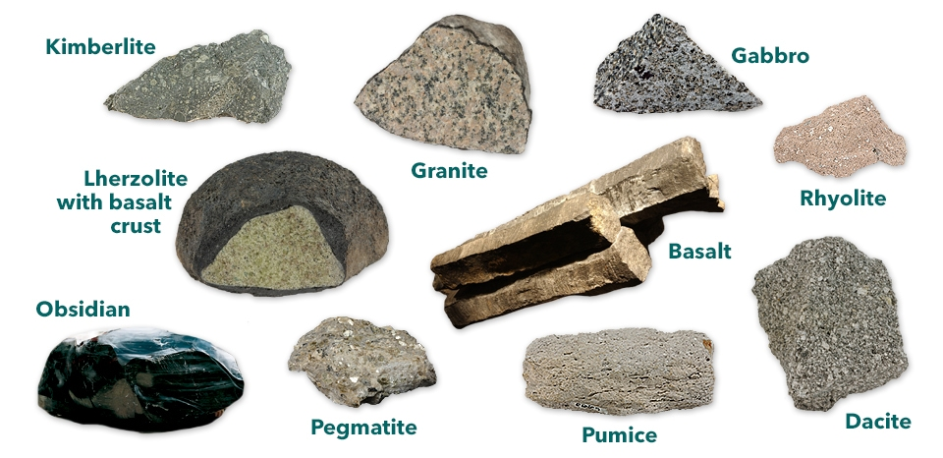 | IGNEOUS  - Magma from deep in the earth is pushed up.  - A volcano erupts and the lava hardens and cools.
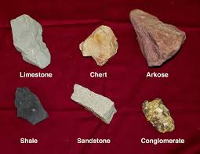 | SEDIMENTARY  - Rocks on the crust are weathered (broken down into smaller pieces), then eroded (picked up and carried to a different location).  - Over many years, the sediments mix with other things like fossils, other rocks, etc. and become sedimentary rock.
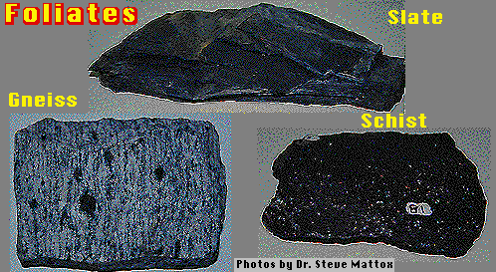 | METAMORPHIC  - Heat and pressure from rock pushed deep in earth’s layers is under a lot of heat and pressure.  - The heat and pressure melt it, changing it into metamorphic rock.
Scroll down for the Rock Cycle picture below….
